Mammals

Lesson 67
Characteristics of mammals
- Mammalian characteristics evolved gradually over a 200-million-year period in the synapsid lineage.
- Two subclasses of mammals evolved during the Mesozoic era—the Prototheria and the Theria. Modern mammals include monotremes, marsupial mammals, and placental mammals.
- The skin of mammals is thick and protective and has an insulating covering of hair.
- Adaptations of teeth and the digestive tract allow mammals to exploit a wide variety of food resources.
- Efficient systems for circulation and gas exchange support the high metabolic rate associated with mammalian endothermy
- The brain of mammals has an expanded cerebral cortex that processes information from various sensory structures.
- Metanephric kidneys permit mammals to excrete urea without excessive water loss.
- Complex behavior patterns enhance mammalian survival
- Most mammals are viviparous and have reproductive cycles that help ensure internal fertilization and successful development.

Lesson 68
Mammals: Evolutionary perspective
The beginning of the Tertiary period, about 70 million years ago, was the start of the “age of mammals.” It coincided with the extinction of many reptilian lineages, which led to the adaptive radiation of the mammals. Tracing the roots of the mammals, however, requires returning to the Carboniferous period, when the synapsid lineage diverged from other amniotic lineages Mammalian characteristics evolved gradually over a period of 200 million years. The early synapsids were the pelycosaurs. Some were herbivores; others showed skeletal adaptations that reflect increased effectiveness as predators.
The anterior teeth of the upper jaw were large and were separated from the posterior teeth by a gap that accommodated the enlarged anterior teeth of the lower jaw when the jaw closed. The palate was arched, which strengthened the upper jaw and allowed air to pass over prey held in the mouth. The legs were longer and slimmer than those of earlier amniotes. By the middle of the Permian period, other successful mammal-like reptiles had arisen from the pelycosaurs. They were a diverse group known as the therapsids. Some were predators, and others were herbivores. In the predatory therapsids, teeth were concentrated at the front of the mouth and enlarged for holding and tearing prey. The posterior teeth were reduced in size and number. The jaws of some therapsids were elongate and generated a large biting force when snapped closed. The teeth of the herbivorous therapsids were also mammal-like. Some had a large space, called the diastema, separating the anterior and posterior teeth. The posterior teeth had ridges (cusps) and cutting
edges that were probably used to shred plant material. Unlike other reptiles, therapsids held hindlimbs directly beneath the body and moved them parallel to the long axis of the body. Changes in the size and shape of the ribs suggest the separation of the trunk into thoracic and ab- dominal regions and a breathing mechanism similar to that of mammals. The last therapsids were a group called the cynodonts (figure 22.2b). Some of these were as large as a big dog, but most were small and little different from the earliest mammals. The first mammals were small (less than 10 cm long) with delicate skeletons. Most knowledge of early mammalian phylogeny comes from the study of their fossilized teeth and skull fragments. These studies suggest that the mammals of the Jurassic and Cretaceous periods were mostly predators that fed on other vertebrates and arthropods. A few were herbivores, and others combined predatory and herbivorous feeding habits. Changes in the structure of the middle ear and the regions of the brain devoted to hearing and olfaction indicate that these senses were important during the early evolution of mammals.
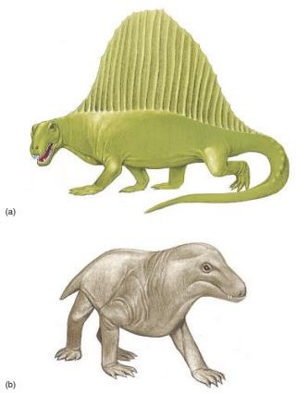
Some zoologists speculate that the small size, well-developed olfactory and auditory abilities, and lack of color vision in most mammals suggest that early mammals were nocturnal. This habit may have allowed them to avoid competition with the much larger dinosaurs and the smaller diur-nal (day-active [L. diurnalis, daily]) reptiles living at the same time. Again, it is speculative, but nocturnal habits could have led to endothermy. Endothermy would have allowed small mammals to maintain body temperatures above that of their surroundings after the sun had set and the air temperature began to fall.

Figure 22.2: Members of the Subclass Synapsidia. (a) Dimetrodon was a 3 m long pelycosaur. It probably fed on other reptiles and amphibians. The large sail may have been a recognition signal and a thermoregulatory device. (b) Cynognathus was a mammal-like reptile that probably foraged for small animals, much like a badger does today. The badger-sized animal was a cynodont within the order Therapsida, the stock from which mammals arose during the mid- Triassic period.

Lesson no. 69

Diversity of Mammals:
Hair, mammary glands, specialized teeth, three middle-ear ossicles, and other characteristics listed in table 22.1 characterize modern members of the class Mammalia (mah-male-ah) (L. mamma, breast).
The subclass Theria diverged into three infraclasses by the late Cretaceous period. The infraclass Ornithodelphia (Gr. ornis, bird delphia, birthplace) contains the monotremes (Gr. monos, one trema, opening). This name refers to the fact that monotremes, unlike other mammals, possess a cloaca. Unlike other mammals, monotremes are oviparous (figure 22.4a, b). The six species of monotremes are found in Australia and New Guinea.
The infraclass Metatheria (Gr. meta, after) contains the marsupial mammals. They are viviparous but have very short gestation periods. A protective pouch, called the marsupium, covers the female mammary glands. The young crawl into the marsupium after birth, where they feed and complete development. About 250 species of marsupials live in the Australian region and the Americas (figure 22.4c; see also figure 22.17).
The other therian infraclass, Eutheria (Gr. eu, true), contains the placental mammals. They are usually born at anadvanced stage of development, having been nourished within the uterus. Exchanges between maternal and fetal circulatory systems occur by diffusion across an organ called the placenta, which is composed of both maternal and fetal tissue. The approximately 3,800 species of eutherians are classified into 17 orders (figures 22.5).

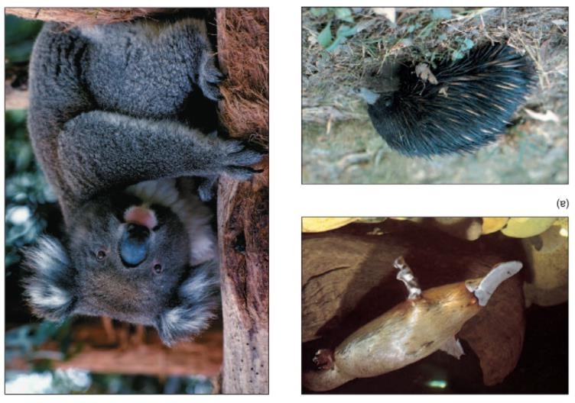
Figure 22.4: Representatives of the Mammalian Infraclasses Ornithodelphia and Metatheria. The infraclass Ornithodelphia: (a) A duck-billed platypus (Ornithorhychus anatinus). (b) An echidna or spiny anteater (Tachyglossus aculeatus). The infraclass Metatheria: (c) The koala (Phascolarctos cinereus) feeds on Eucalyptus leaves in Australia.
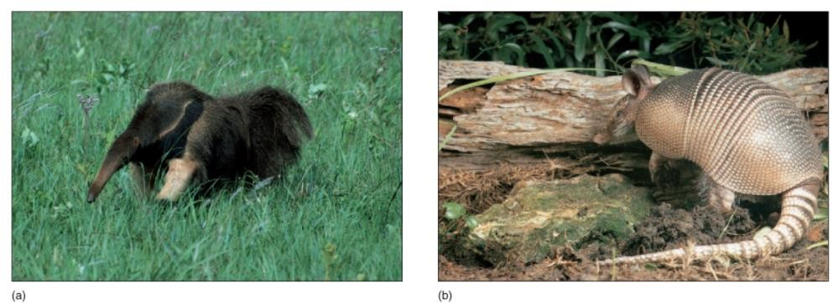
Order Edentata. (a) A giant anteater (Myrmecophaga tridactyla). Anteaters lack teeth. They use powerful forelimbs to tear into an insect nest and a long tongue covered with sticky saliva to capture prey. (b) An armadillo (Dasypus novemcinctus).

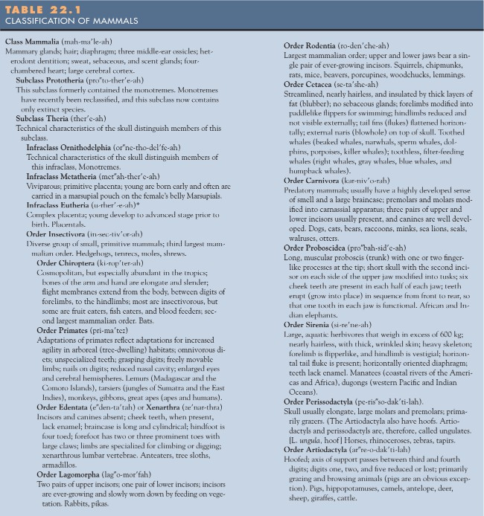

Lesson 70

Evolutionary perspective
Mammals are naturally distributed on all continents except Antarctica, and they live in all oceans. This section discusses the many adaptations that have accompanied their adaptive radiation.

EXTERNAL STRUCTURE AND LOCOMOTION
The skin of a mammal, like that of other vertebrates, consists of epidermal and dermal layers. It protects from mechanical injury, invasion by microorganisms, and the sun’s ultraviolet light. Skin is also important in temperature regulation, sensory perception, excretion, and water regulation (see figure below). Hair is a keratinized derivative of the epidermis of the skin and is uniquely mammalian. It is seated in an invagination of the epidermis, called a hair follicle. A coat of hair, called pelage, usually consists of two kinds of hair. Long guard hairs protect a dense coat of shorter, insulating under hairs. Because hair is composed largely of dead cells, it must be periodically molted. In some mammals (e.g., humans), molting occurs gradually and may not be noticed. In others, hair loss occurs rapidly and may result in altered pelage characteristics. In the fall, many mammals acquire a thick coat of insulating under hair, and he pelage color may change. For example, the Arctic fox takes on a white or cream color with its autumn molt, which helps conceal the fox in a snowy environment. With its spring molt, the Arctic fox acquires a gray and yellow pelage (see figure 22.6). Hair is also important for the sense of touch. Mechanical displacement of a hair stimulates nerve cells associated with the hair root. Guard hairs may sometimes be modified into thick-shafted hairs called vibrissae. Vibrissae occur around the legs, nose, mouth, and eyes of many mammals. Their roots are richly innervated and very sensitive to displacement.
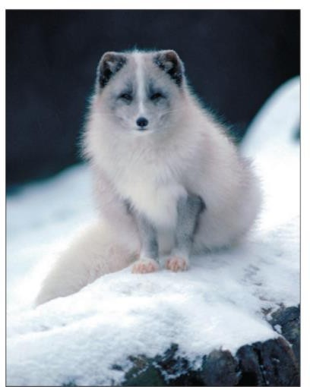

Figure 22.6: Order Carnivora. An Arctic fox (Alopex lagopus) with its winter pelage. With its spring molt, the Arctic fox acquires a gray and yellow colored coat.

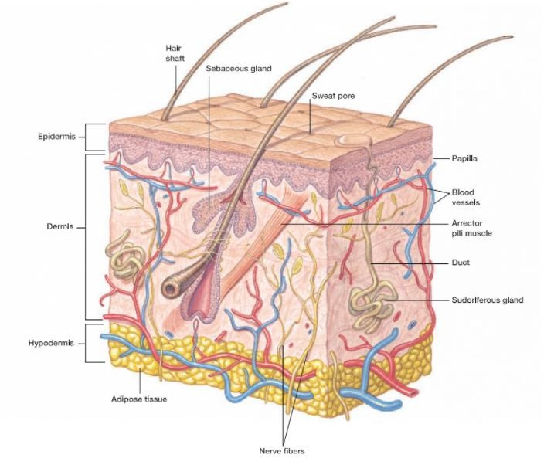
Figure: Skin of Mammals. Notice the various structures in the dermis of human skin.

Air spaces in the hair shaft and air trapped between hair and the skin provide an effective insulating layer. A band of smooth muscle, called the arrector pili muscle, runs between the hair follicle and the lower epidermis. When the muscle contracts, the hairs stand upright, increasing the amount of air trapped in the pelage and improving its insulating properties. Arrector pili muscles are under the control of the autonomic nervous system, which also controls a mammal’s “fight-or-flight” response. In threatening situations, the hair (especially on the neck and tail) stands on end and may give the perception of increased size and strength.
Hair color depends on the amount of pigment (melanin) deposited in it and the quantity of air in the hair shaft. The pelage of most mammals is dark above and lighter underneath. This pattern makes them less conspicuous under most conditions. Some mammals advertise their defenses using aposematic (warning) coloration. The contrasting markings of a skunk are a familiar example. Pelage is reduced in large mammals from hot climates (e.g., elephants and hippopotamuses) and in some aquatic mammals (e.g., whales) that often have fatty insulation. A few mammals (e.g., naked mole rats) have almost no pelage. Claws are present in all amniote classes. They are used for locomotion and offensive and defensive behavior. Claws form from accumulations of keratin that cover the terminal phalanx (bone) of the digits. In some mammals, they are specialized to form nails or hooves (figure 22.7).
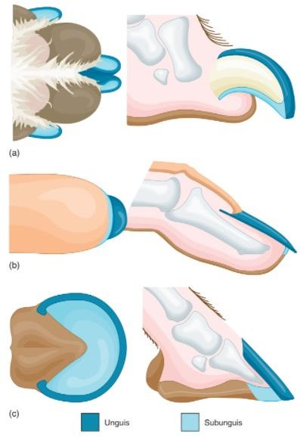
Figure 22.7: Structure of Claws, Nails, and Hooves. (a) Claws. (b) Nails are flat, broad claws found on the hands and feet of primates and are an adaptation for arboreal habits, where grasping is essential. (c) Hooves are characteristic of ungulate mammals. The number of toes is reduced, and the animals walk or run on the tips of the remaining digits. The unguis is a hard, keratinized dorsal plate, and the subunguis is a softer ventral plate.

Glands develop from the epidermis of the skin. Sebaceous (oil) glands are associated with hair follicles, and their oily secretion lubricates and waterproofs the skin and hair. Most mammals also possess sudoriferous (sweat) glands. Small sudoriferous glands (eccrine glands) release watery secretions used in evaporative cooling. Larger sudoriferous glands (apocrine glands) secrete a mixture of salt, urea, and water, which microorganisms on the skin convert to odorous products.
Scent or musk glands are around the face, feet, or anus of many mammals. These glands secrete pheromones, which may be involved with defense, species and sex recognition, and territorial behavior. Mammary glands are functional in female mammals and are present, but nonfunctional, in males. The milk that mammary glands secrete contains water, carbohydrates (especially the sugar lactose), fat, protein, minerals, and antibodies. Mammary glands are probably derived evolutionarily from apocrine glands and usually contain substantial fatty deposits. Monotremes have mammary glands that lack nipples. The glands discharge milk into depressions on the belly, where the young lap it up. In other mammals, mammary glands open via nipples or teats, and the young suckle for their nourishment (figure 22.8).
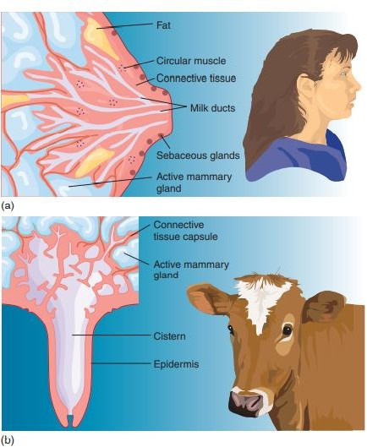
Figure 22.8: Mammary Glands. Mammary glands are specialized to secrete milk following the birth of young. (a) In humans, many ducts lead from the glands to a nipple. Parts of the duct system are enlarged to store milk. Suckling by an infant initiates a hormonal response that causes the mammary glands to release milk. (b) Some mammals (e.g., cattle) have teats that form by the extension of a collar of skin around the opening of mammary ducts. Milk collects in a large cistern prior to its release. The number of nipples or teats varies with the number of young produced

Lesson no. 72

The Skull and Teeth
The skulls of mammals show important modifications of the reptilian pattern. One feature that zoologists use to distinguish reptilian from mammalian skulls is the method of jaw articulation. In reptiles, the jaw articulates at two small bones at the rear of the jaw. In mammals, these bones have moved into the middle ear, and along with the stapes, form the middle-ear ossicles. A single bone of the lower jaw articulates the mammalian jaw. A secondary palate evolved twice in vertebrates—in the archosaur lineage and in the synapsid lineage. In some therapsids, small, shelflike extensions of bone (the hard palate) partially separated the nasal and oral passageways. In mammals, the secondary palate extends posteriorly by a fold of skin, called the soft palate, which almost completely separates the nasal passages from the mouth cavity. Unlike other vertebrates that swallow food whole or in small pieces, some mammals chew their food. The more extensive secondary palate allows mammals to breathe while chewing. Breathing needs to stop only briefly during swallowing (figure 22.9). The structure and arrangement of teeth are important indicators of mammalian lifestyles. In reptiles, the teeth are uniformly conical, a condition referred to as homodont. In mammals, the teeth are often specialized for different functions, a condition called heterodont. Reptilian teeth attach along the top or inside of the jaw, whereas in mammals, the teeth are set into sockets of the jaw. Most mammals have two sets of teeth during their lives.

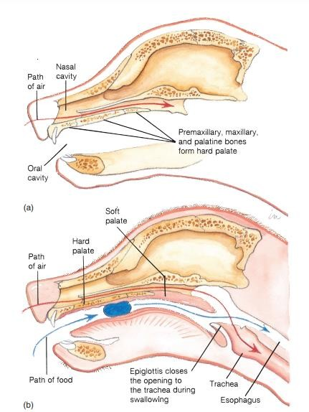

Figure 22.9: Secondary Palate. (a) The secondary palate (consisting of the hard and soft palates) of a mammal almost completely separates the nasal and oral cavities. (b) Breathing stops only momentarily during swallowing.

The first teeth emerge before or shortly after birth and are called deciduous or milk teeth. These teeth are lost, and permanent teeth replace them. Adult mammals have up to four kinds of teeth. Incisors are the most anterior teeth in the jaw. They are usually chisel-like and used for gnawing or nipping. Canines are often long, stout, and conical, and are usually used for catching, killing, and tearing prey. Canines and incisors have single roots. Premolars are positioned next to canines, and have one or two roots and truncated surfaces for chewing. Molars have broad chewing surfaces and two (upper molars) or three (lower molars) roots.
Mammalian species have characteristic numbers of each kind of adult tooth. Zoologists use a dental formula to characterize taxa. It is an expression of the number of teeth of each kind in one-half of the upper and lower jaws. The teeth of the upper jaw are listed above those of the lower jaw and in the following order: incisors, canine, premolars, and molars. For example:
Human Beaver 2•1•2•3 1•0•1•3
2•1•2•3 1•0•1•3

Mammalian teeth (dentition) may be specialized for particular diets. In some mammals, the dentition is reduced, sometimes to the point of having no teeth. For example, armadillos and the giant anteater (order Edentata) feed on termites and ants, and their teeth are reduced. Some mammals (e.g., humans, order Primates; and pigs, order Artiodactyla) are omnivorous; they feed on a variety of plant and animal materials. They have anterior teeth with sharp ripping and piercing surfaces, and posterior teeth with flattened grinding surfaces for rupturing plant cell walls. Mammals that eat plant material often have flat, grinding posterior teeth and incisors, and sometimes have canines modified for nipping plant matter (e.g., horses, order Perissodactyla; deer, order Artiodactyla) or gnawing (e.g., rabbits, order Lagomorpha; beavers, order Rodentia). In rodents, the incisors grow throughout life. Although most mammals have enamel covering the entire tooth, rodents have enamel only on the front surfaces of their incisors. The teeth are kept sharp by slower wear in front than in back. A gap called the diastema separates the anterior food- procuring teeth from the posterior grinding teeth. The diastema results from an elongation of the snout that allows the anterior teeth to reach close to the ground or into narrow openings to procure food. The posterior teeth have a high, exposed surface (crown) and continuous growth, which allows these teeth to withstand years of grinding tough vegetation. Predatory mammals use canines and incisors for catching, killing, and tearing prey. In members of the order Carnivora (e.g., coyotes, dogs, and cats), the fourth upper premolars and first lower molars form a scissorlike shearing surface, called the carnassial apparatus, that is used for cutting flesh from prey.

Lesson 73
The Vertebral Column and Appendicular Skeleton
The vertebral column of mammals is divided into five regions. As with reptiles and birds, the first two cervical vertebrae are the atlas and axis. Five other cervical vertebrae usually follow. Even the giraffe and the whale have seven neck vertebrae, which are greatly elongate or compressed, respectively. In contrast, tree sloths have either six or nine cervical vertebrae, and the manatee has six cervical vertebrae.
The trunk is divided into thoracic and lumbar regions, as is the case for birds. In mammals, the division is correlated with their method of breathing. The thoracic region contains the ribs.
Most ribs connect to the thoracic vertebrae and to the sternum via costal cartilages. Other ribs attach only to the thoracic vertebrae or to other ribs through cartilages. All ribs protect the heart and lungs. The articulation between the thoracic vertebrae provides the flexibility needed in turning, climbing, and lying on the side to suckle young. Lumbar vertebrae have interlocking processes that give support, but little freedom of movement. The appendicular skeleton of mammals rotates under the body so that the appendages are usually directly beneath the body. Joints usually limit the movement of appendages to a single anteroposterior plane, causing the tips of the appendages to move in long arcs. The bones of the pelvic girdle are fused in the adult, a condition that is advantageous for locomotion but presents problems during the birth of offspring. In a pregnant female, the ventral joint between the halves of the pelvis—the pubic symphysis— loosens before birth, allowing the pelvis to spread during birth.

Muscles
Because the appendages are directly beneath the body of most mammals, the skeleton bears the weight of the body. Muscle mass is concentrated in the upper appendages and girdles. Many running mammals (e.g., deer, order Artiodactyla) have little muscle in their lower leg that would slow leg movement. Instead, tendons run from muscles high in the leg to cause movement at the lower joints.

Lesson 74
NUTRITION AND THE DIGESTIVE SYSTEM
The digestive tract of mammals is similar to that of other vertebrates but has many specializations for different feeding habits. Some specializations of teeth have already been described. The feeding habits of mammals are difficult to generalize. Feeding habits reflect the ecological specializations that have evolved. For example, most members of the order Carnivora feed on animal flesh and are, therefore, carnivores. Other members of the order, such as bears, feed on a variety of plant and animal products and are omnivores. Some carnivorous mammals are specialized for feeding on arthropods or soft-bodied invertebrates, and are often referred to (rather loosely) as insectivores. These include animals in the orders Insectivora (e.g., shrews), Chiroptera (bats), and Edentata (anteaters). Herbivores such as deer (order Artiodactyla) and zebras (order Perissodactyla) feed mostly on vegetation, but their diet also includes invertebrates inadvertently ingested while feeding.
Specializations in the digestive tract of most herbivores reflect the difficulty of digesting food rich in cellulose. Horses, rabbits, and many rodents have an enlarged cecum at the junction of the large and small intestines. A cecum is a fermentation pouch where microorganisms aid in cellulose digestion. Sheep, cattle, and deer are called ruminants (L. ruminare, to chew the cud). Their stomachs are modified into four chambers. The first three chambers are storage and fermentation chambers and contain microorganisms that synthesize a cellulose-digesting enzyme (cellulase). Gases that fermentation produces are periodically belched, and some plant matter (cud) is regurgitated and rechewed. Other microorganisms convert nitrogenous compounds in the food into new proteins.

Lesson 75

CIRCULATION
The hearts of birds and mammals are superficially similar. Both are four-chambered pumps that keep blood in the systemic and pulmonary circuits separate, and both evolved from the hearts of ancient reptiles. Their similarities, however, are a result of adaptations to active lifestyles. The evolution of similar structures in different lineages is called convergent evolution. The mammalian heart evolved in the synapsid reptilian lineage, whereas the avian heart evolved in the archosaur lineage (figure 22.12).
One of the most important adaptations in the circulatory system of eutherian mammals concerns the distribution of respiratory gases and nutrients in the fetus (figure 22.13a). Exchanges between
maternal and fetal blood occur across the placenta. Although maternal and fetal blood vessels are intimately associated, no blood actually mixes. Nutrients, gases, and wastes simply diffuse between fetal and maternal blood supplies. Blood entering the right atrium of the fetus is returning from the placenta and is highly oxygenated. Because fetal lungs are not inflated, resistance to blood flow through the pulmonary arteries is high. Therefore, most of the blood entering the right atrium bypasses the right ventricle and passes instead into the left atrium through a valved opening between the atria (the foramen ovale). Some blood from the right atrium, however, does enter the right ventricle and the pulmonary artery. Because of the resistance at the uninflated lungs, most of this blood is shunted to the aorta through a vessel connecting the aorta and the left pulmonary artery (the ductus arteriosus). At birth, the placenta is lost, and the lungs are inflated. Resistance to blood flow through the lungs is reduced, and blood flow to them increases. Flow through the ductus arteriosus decreases, and the vessel is gradually reduced to a ligament. Blood flow back to the left atrium from the lungs correspondingly increases, and the valve of the foramen ovale closes and gradually fuses with the tissue separating the right and left atria (figure 22.13b).
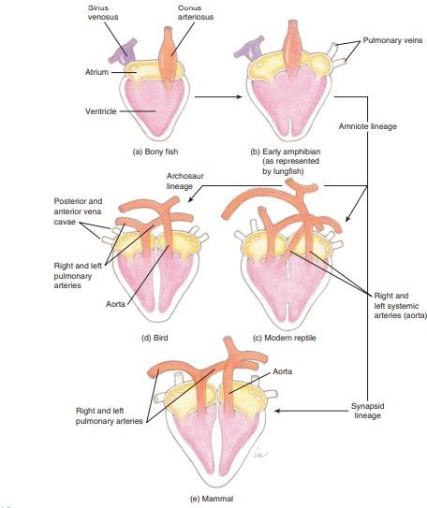
Figure 22.12: Possible Sequence in the Evolution of the Vertebrate Heart. (a) Diagrammatic representation of a bony fish heart. (b) In lungfish, partially divided atria and ventricles separate pulmonary and systemic circuits. This heart was probably similar to that in primitive amphibians and
early amniotes. (c) The hearts of modern reptiles were derived from the pattern in (b). (d) The archosaur and (e) synapsid lineages resulted in completely separated, four-chambered hearts

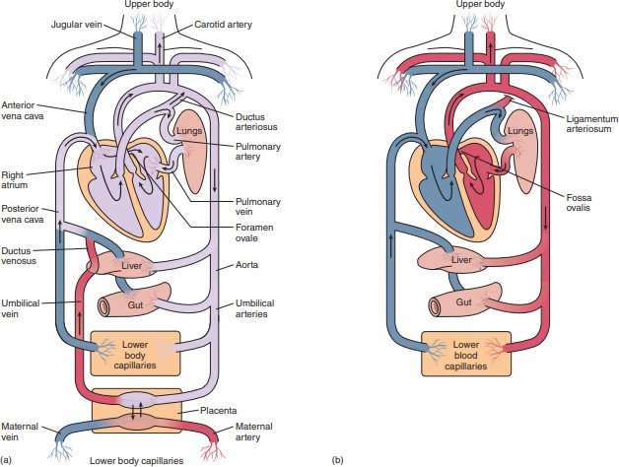
Figure 22.13: Mammalian Circulatory Systems. The circulatory patterns of (a) fetal and (b) adult mammals. Highly oxygenated blood is shown in red, and less oxygenated blood is shown in blue. In fetal circulation, highly oxygenated blood from the placenta mixes with less oxygenated blood prior to entering the right atrium. Thus, most arterial blood of the fetus is moderately oxygenated. The pale lavender color in (a) symbolizes this state of oxygenation.

Lesson 76

Gas Exchange
High metabolic rates require adaptations for efficient gas exchange. Most mammals have separate nasal and oral cavities and longer snouts, which provide an increased surface area for warming and moistening inspired air. Respiratory passageways are highly branched, and large surface areas exist for gas exchange. Mammalian lungs resemble a highly vascular sponge, rather than the saclike structures of amphibians and a few reptiles. Mammalian lungs, like those of reptiles, inflate using a negative-pressure mechanism. Unlike reptiles and birds, however, mammals possess a muscular diaphragm that separates the thoracic and abdominal cavities. Inspiration results from contraction of the diaphragm and expansion of the rib cage, both of which decrease the intrathoracic pressure and allow air to enter the lungs. Expiration is normally by elastic recoil of the lungs and relaxation of inspiratory muscles, which decreases the volume of the thoracic cavity. The contraction of other thoracic and abdominal muscles can produce forceful exhalation.

Lesson 77
Temperature Regulation
Mammals are widely distributed over the earth, and some face harsh environmental temperatures. Nearly all face temperatures that require them to dissipate excess heat at some times and to conserve and generate heat at other times. Heat-producing mechanisms of mammals are divided into two categories. Shivering thermogenesis is muscular activity that generates large amounts of heat but little movement. Nonshivering thermogenesis involves heat production by general cellular metabolism and the metabolism of special fat deposits called brown fat.
Heat production is effective in thermoregulation because mammals are insulated by their pelage and/or fat deposits. Fat deposits are also sources of energy to sustain high metabolic rates. Mammals without a pelage can conserve heat by allowing the temperature of surface tissues to drop. A walrus in cold, arctic waters has a surface temperature near 0° C; however, a few centimeters below the skin surface, body temperatures are about 35° C.
Upon emerging from the icy water, the walrus quickly warms its skin by increasing peripheral blood flow. Most tissues cannot tolerate such rapid and extreme temperature fluctuations. Further investigations are likely to reveal some unique biochemical characteristics of these skin tissues. Even though most of the body of an arctic mammal is unusually well insulated, appendages often have thin coverings of fur as an adaptation to changing thermoregulatory needs. Even in winter, an active mammal sometimes produces more heat than is required to maintain body temperature. Patches of poorly insulated skin allow excess heat to be dissipated. During periods of inactivity or extreme cold, however, arctic mammals must reduce heat loss from these exposed areas, often by assuming heat-conserving postures. Mammals sleeping in cold environments conserve heat by tucking poorly insulated appendages and their faces under well-insulated body parts.
Countercurrent heat-exchange systems may help regulate heat loss from exposed areas (figure 22.14). Arteries passing peripherally through the core of an appendage are surrounded by veins that carry blood back toward the body. When blood returns to the body through these veins, heat transfers from arterial blood to venous blood and returns to the body rather than being lost to the environment. When excess heat is produced, blood is shunted away from the countercurrent veins toward peripheral vessels, and excess heat is radiated to the environment.

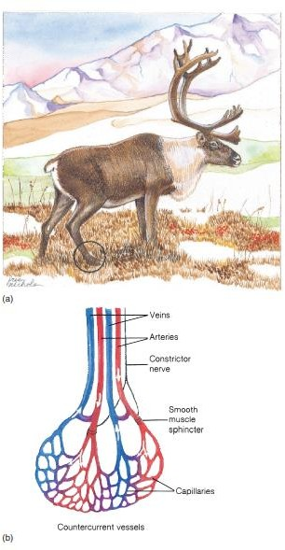

Figure 22.14: Countercurrent Heat Exchange. Countercurrent heat exchangers conserve body heat in mammals adapted to cold environments. (a) Systems similar to the one depicted here are found in the legs of reindeer (Rangifer tarandus) and in the flippers of dolphins. (b) Heat transferred from blood moving peripherally in arteries warms venous blood returning from an extremity. During winter, the lower part of a reindeer’s leg may be at 10°C, while body temperature is about 40°C. White arrows indicate direction of blood flow.

Mammals have few problems getting rid of excess heat in cool, moist environments. Heat can be radiated into the air from vessels near the surface of the skin or lost by evaporative cooling from either sweat glands or respiratory surfaces during panting. Hot, dry environments present far greater problems, because evaporative cooling may upset water balances. Jackrabbits and elephants use their long ears to radiate heat. Small mammals often avoid the heat by remaining in burrows during the day and foraging for food at night. Other mammals seek shade or watering holes for cooling.

Lesson 78
Winter Sleep and Hibernation
Mammals react in various ways to environmental extremes. Caribou migrate to avoid extremes of temperature, and wildebeest migrate to avoid seasonal droughts. Other mammals retreat to burrows under the snow, where they become less active but are still relatively alert and easily aroused—a condition called winter sleep. For example, bears and raccoons retreat to dens in winter. Their body temperatures and metabolic rates decrease somewhat, but they do not necessarily remain inactive all winter.

Hibernation is a period of winter inactivity in which the hypothalamus of the brain slows the metabolic, heart, and respiratory rates. True hibernators include the monotremes (echidna and duck-billed platypus) and many members of the Insectivora (e.g., moles and shrews), Rodentia (e.g., chipmunks and woodchucks), and Chiroptera (bats). In preparation for hibernation, mammals usually accumulate large quantities of body fat. After a hibernating mammal retreats to a burrow or a nest, the hypothalamus sets the body’s thermostat to about 2° C. The respiratory rate of a hibernating ground squirrel falls from 100 to 200 breaths per minute to about four breaths per minute. The heart rate falls from 200 to 300 beats per minute to about 20 beats per minute. During hibernation, a mammal may lose a third to half of its body weight. Arousal from hibernation occurs by metabolic heating, frequently using brown fat deposits, and it takes several hours to raise body temperature to near 37° C.

Lesson 79

NERVOUS AND SENSORY FUNCTIONS
The basic structure of the vertebrate nervous system is retained in mammals. The development of complex nervous and sensory functions goes hand-in-hand with active lifestyles and is most evident in the enlargement of the cerebral hemispheres and the cerebellum of mammals. Most integrative functions shift to the enlarged cerebral cortex (neocortex). In mammals, the sense of touch is well developed. Receptors are associated with the bases of hair follicles and are stimulated when a hair is displaced. Olfaction was apparently an important sense in early mammals, because fossil skull fragments show elongate snouts, which would have contained olfactory epithelium. Cranial casts of fossil skulls show enlarged olfactory regions. Olfaction is still an important sense for many mammals. Mammals can perceive olfactory stimuli over long distances during either the day or night to locate food, recognize members of the same species, and avoid predators.
Auditory senses were similarly important to early mammals. More recent adaptations include an ear flap (the pinna) and the external ear canal leading to the tympanum that directs sound to the middle ear. The middle ear contains three ear ossicles that conduct vibrations to the inner ear. The sensory patch of the inner ear that contains the sound receptors is long and coiled and is called the cochlea. This structure provides more surface area for receptor cells and gives mammals greater sensitivity to pitch and volume than is present in reptiles. Cranial casts of early mammals show well-developed auditory regions.
Vision is an important sense in many mammals, and eye structure is similar to that described for other vertebrates. Accommodation occurs by changing the shape of the lens (see figure 24.29). Color vision is less well developed in mammals than in reptiles and birds. Rods dominate the retinas of most mammals, which supports the hypothesis that early mammals were nocturnal. Primates, squirrels, and a few other mammals have well-developed color vision.

Lesson 80
EXCRETION AND OSMOREGULATION
Mammals, like all amniotes, have a metanephric kidney. Unlike reptiles and birds, which excrete mainly uric acid, mammals excrete urea. Urea is less toxic than ammonia and does not require large quantities of water in its excretion. Unlike uric acid, however, urea is highly water soluble and cannot be excreted in a semisolid form; thus, some water is lost. Excretion in mammals is always a major route for water loss.
In the nephron of the kidney, fluids and small solutes are filtered from the blood through the walls of a group of capillary-like vessels, called the glomerulus. The remainder of the nephron consists of tubules that reabsorb water and essential solutes and secrete particular ions into the filtrate. The primary adaptation of the mammalian nephron is a portion of the tubule system called the loop of the nephron. The transport processes in this loop and the remainder of the tubule system allow mammals to produce urine that is more concentrated than blood. For example, beavers produce urine that is twice as concentrated as blood, while Australian hopping mice produce urine that is 22 times more concentrated than blood. This accomplishes the same function that nasal and orbital salt glands do in reptiles and birds.
Water loss varies greatly, depending on activity, physiological state, and environmental temperature. Water is lost in urine, feces, and evaporation from sweat glands and respiratory surfaces, and during nursing. Mammals in very dry environments have many behavioral and physiological mechanisms to reduce water loss. The kangaroo rat, named for its habit of hopping on large hind legs, is capable of extreme water conservation (figure 22.15). It is native to the southwestern deserts of the United States and Mexico, and it survives without drinking water. Its feces are almost dry, and its nocturnal habits reduce evaporative water loss.
Condensation as warm air in the respiratory passages encounters the cooler nasal passages minimizes respiratory water loss. A low-protein diet, which reduces urea production, minimizes excretory water loss. The nearly dry seeds that the kangaroo rat eats are rich sources of carbohydrates and fats. Metabolic oxidation of carbohydrates produces water as a by-product.

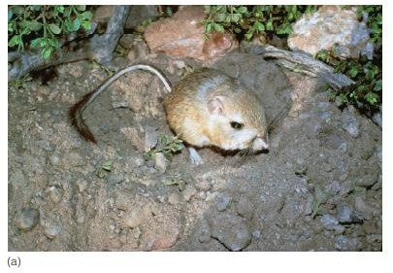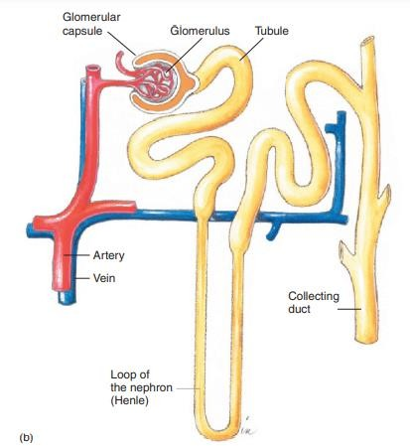
Figure 22.15
Order Rodentia. (a) The kangaroo rat (Dipodomys ordii). (b) The long loop of the nephron of this desert animal conserves water, preventing dehydration.

Lesson 81
Behavior of mammals
Mammals have complex behaviors that enhance survival. Visual cues are often used in communication. The bristled fur, arched back, and open mouth of a cat communicate a clear message to curious dogs or other potential threats. A tail-wagging display of a dog has a similarly clear message. A wolf defeated in a fight with other wolves lies on its back and exposes its vulnerable throat and belly. Similar displays may allow a male already recognized as being subordinate to another male to avoid conflict within a social group. Pheromones are used to recognize members of the same species, members of the opposite sex, and the reproductive state of a member of the opposite sex. Pheromones may also induce sexual behavior, help establish and recognize territories, and ward off predators. The young of many mammalian species recognize their parents, and parents recognize their young, by smell. Bull elk smell the rumps of females during the breeding season to recognize those in their brief receptive period. They also urinate on their own bellies and underhair to advertise their reproductive status to females and other males. Male mammals urinate on objects in the environment to establish territories and to allow females to become accustomed to their odors. Rabbits and rodents spray urine on a member of the opposite sex to inform the second individual of the first’s readiness to mate. Skunks use chemicals to ward off predators.
Auditory and tactile communication are also important in the lives of mammals. Herd animals stay together and remain calm as long as familiar sounds (e.g., bellowing, hooves walking over dry grasses and twigs, and rumblings from ruminating stomachs) are uninterrupted. Unfamiliar sounds may trigger alarm and flight.
Vocalizations and tactile communication are important in primate social interactions. Tactile communication ranges from precopulatory “nosing” that occurs in many mammals to grooming. Grooming helps maintain a healthy skin and pelage, but also reinforces important social relationships within primate groups.

Lesson 82 Territoriality
Many mammals mark and defend certain areas from intrusion by other members of the same species. When cats rub their face and neck on humans or on furniture, the behavior is often interpreted as affection. Cats, however, are really staking claim to their territory, using odors from facial scent glands. Some territorial behavior attracts females to, and excludes other males from, favorable sites for mating and rearing young. Male California sea lions (Zalophus californianus) establish territories on shorelines where females come to give birth to young. For about two weeks, males engage in vocalizations, displays, and sometimes serious fighting to stake claim to favorable territories. Older, dominant bulls are usually most successful in establishing territories, and young bulls generally swim and feed just offshore. When they arrive at the beaches, females select a site for giving birth. Selection of the birth site also selects the bull that will father next year’s offspring. Mating occurs approximately two weeks after the birth of the previous year’s off-spring. Development is arrested for the three months during which the recently born young do most of their nursing. This mechanism is called embryonic diapause. Thus, even though actual development takes about nine months, the female carries the embryo and fetus for a period of one year.

Lesson 83

Reproduction and development
In no other group of animals has viviparity developed to the extent it has in mammals. Mammalian viviparity requires a large expenditure of energy on the part of the female during development and on the part of one or both parents caring for young after they are born. Viviparity is advantageous because females are not necessarily tied to a single nest site, but can roam or migrate to find food or a proper climate. Viviparity is accompanied by the evolution of a portion of the reproductive tract where the young are nourished and develop. In viviparous mammals, the oviducts are modified into one or two uteri (sing., uterus).

Reproductive Cycles
Most mammals have a definite time or times during the year in which ova (eggs) mature and are capable of being fertilized. Reproduction usually occurs when climatic conditions and resource characteristics favor successful development. Mammals living in environments with few seasonal changes and those that exert considerable control over immediate environmental conditions (e.g., humans) may reproduce at any time of the year. However, they are still tied to physiological cycles of the female that determine when ova can be fertilized.
Most female mammals undergo an estrus (Gr. oistros, a vehement desire) cycle, which includes a time during which the female is behaviorally and physiologically receptive to the male. During the estrus cycle, hormonal changes stimulate the maturation of ova in the ovary and induce ovulation (release of one or more mature ova from an ovarian follicle). A few mammals (e.g., rabbits, ferrets, and mink) are induced ovulators; coitus (copulation) induces ovulation.

Lesson 84:

Reproductive cycles 1
Hormones also mediate changes in the uterus and vagina. As the ova are maturing, the inner lining of the uterus proliferates and becomes more vascular in preparation for receiving developing embryos. External swelling in the vaginal area and increased glandular discharge accompany the proliferation of vaginal mucosa. During this time, males show heightened interest in females, and females are receptive to males. If fertilization does not occur, the changes in the uterus and vagina are reversed until the next cycle begins. No bleeding or sloughing of uterine lining usually occurs.
Many mammals are monestrus and have only a single yearly estrus cycle that is sharply seasonal. Wild dogs, bears, and sea lions are monestrus; domestic dogs are diestrus. Other mammals are polyestrus. Rats and mice have estrus cycles that repeat every four to six days. The menstrual cycle of female humans, apes, and monkeys is similar to the estrus cycle in that it results in a periodic proliferation of the inner lining of the uterus and correlates with the maturation of an ovum. If fertilization does not occur before the end of the cycle, menses—the sloughing of the uterine lining—occurs.

Lesson 85
Fertilization in Mammals
Fertilization-usually occurs in the upper third of the oviduct within hours of copulation. In a few mammals, fertilization may be delayed. In some bats, for example, coitus occurs in autumn, but fertilization is delayed until spring. Females store sperm in the uterus for periods in excess of two months. This delayed fertilization is apparently an adaptation to winter dormancy. Fertilization can occur immediately after females emerge from dormancy rather than waiting until males attain their breeding state.
In many other mammals, fertilization occurs right after coitus, but development is arrested after the first week or two. This embryonic diapause, which was described previously for sea lions, also occurs in some bats, bears, martens, and marsupials. The adaptive significance of embryonic diapause varies with species. In the sea lion, embryonic diapause allows the mother to give birth and mate within a short interval, but not have her resources drained by both nursing and pregnancy. It also allows young to be born at a time when resources favor their survival. In some bats, fertilization occurs in the fall before hibernation, but birth is delayed until resources become abundant in the spring.

Lesson 86
Modes of Development
Monotremes are oviparous. The ovaries release ova with large quantities of yolk. After fertilization, shell glands in the oviduct deposit a shell around the ovum, forming an egg. Female echidnas incubate eggs in a ventral pouch. Platypus eggs are laid in their burrows.
All other mammals have a placenta through which young are nourished for at least a portion of their development. The maternal bloodstream, not yolk, supplies nutrients. In marsupials, most nourishment for the fetus comes from “uterine milk” that uterine cells secrete. Some nutrients diffuse from maternal blood into a highly vascular yolk sac that makes contact with the uterus. This connection in marsupials is a primitive placenta. The marsupial gestation period (the length of time young develop within the female reproductive tract) varies between 8 and 40 days in different species. The gestation period is short because of marsupials’ inability to sustain the production of hormones that maintain the uterine lining. After birth, tiny young crawl into the marsupium and attach to a nipple, where they suckle for an additional 60 to 270 days (figure 22.17).

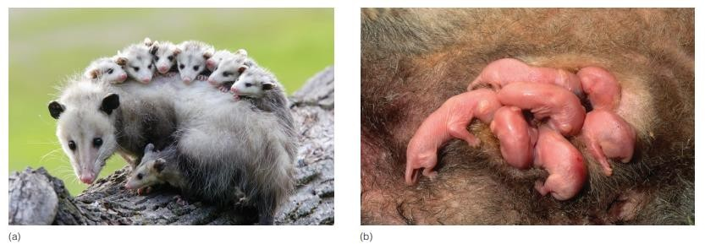

Figure 22.17
Order Marsupialia. (a) The Virginia opossum (Didelphis virginiana) is found throughout Central America and is the only opossum found in North America. (b) Opossum young nursing in a marsupial pouch.

In eutherian mammals, the embryo implants deeply into the uterine wall. Embryonic and uterine tissues grow rapidly and be-come highly folded and vascular, forming the placenta. Although maternal and fetal blood do not mix, nutrients, gases, and wastes diffuse between the two bloodstreams. Gestation periods of eutherian mammals vary from 20 days (some rodents) to 19 months (the African elephant). Following birth, the placenta and other tissues that surrounded the fetus in the uterus are expelled as “afterbirth.” The newborns of many species (e.g., humans) are helpless at birth; others (e.g., deer and horses) can walk and run shortly after birth.

